**Output:**

1. **Menu**

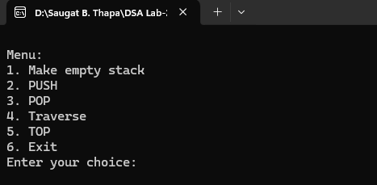

1. **Empty Stack**

1. **PUSH**

1. **POP**

1. **Traverse**

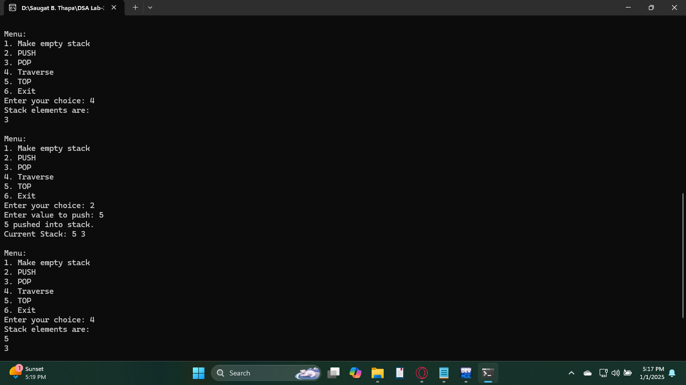

1. **TOP**

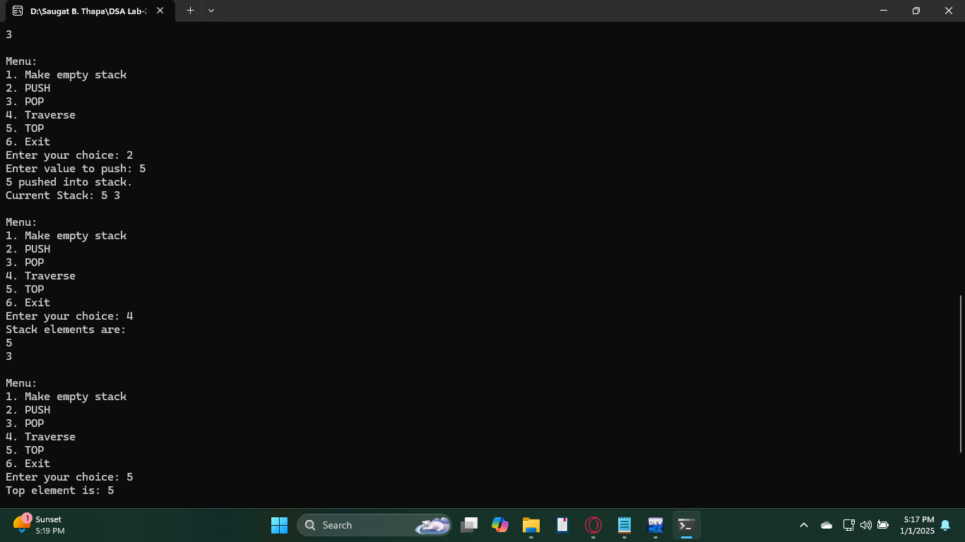

1. **Exit**

